## ***Contextualizing the Ceremony***

*By: Steven and Sasha*

## ***GENERAL OVERVIEW***

* Describe what your project is about.

This experience allows visitors to navigate to previous topics, objects and information explored during the guided tour. We are proposing a non-intrusive timeline that will have interactive timestamps coinciding with when certain objects were introduced during the tour. Visitors can seamlessly navigate back to a topic of interest and then back to the current state of the guided tour. We are driven to make this experience because of the importance of contextualizing objects within the exhibition. While the guided tour provides the opportunity for close guidance by an expert of the exhibit, visitors are not able to explore previous objects discussed by the tour guide in the current state of the application.

* Describe why this project is relevant to its medium.

While exploring the timeline of objects, visitors would be able to see them augmented in the space they are in at the moment. Interacting with objects in a physical space would allow for a better understanding of how rituals and ceremonies in the House of the Abelam were carried out, and the relative significance of each of the objects in these processes. Having multiple objects in the same space would also help to have a better understanding of how they compared in size and color/texture to one another, as well as how they looked in comparison to the main parts of the exhibit such as the House of the Abelam itself and the chambers.

* Describe the learning experience that you want to suggest in your audience.

While the experience is being mediated by the tour guide, we want to engage visitors to take a proactive approach to the exploration of the object. Presented with 3D models of all the objects they already learned about, the visitors would be expected to reflect on what they have seen, and make connections or juxtapose in ways that feel intuitive to them. The interactions that would allow them to do it is the presentation of objects in a timeline mode, and letting the user see multiple objects in front of them at a time.

* Are there any unusual aspects?

We want to take the current state of the application and develop a feature that takes into account the inevitable disparities in how visitors prefer to navigate museums and engage with information during tours. We intend to focus on balancing the purpose of a guided tour (engaging with an expert) with the autonomy to make connections and explore on your own. The user experience of making this feature noticeable yet not one for visitors to use in place of paying attention to the tour guide/disrupting the tour is our primary design challenge.

## ***DESIGN OVERVIEW***

* Describe the context of your project.

The square in front of the House of the Abelam was central for political and social life. However, the whole process of initiations was covered in secrecy and exclusivity, with many parts of the experience being restricted to the most influential men of the society. With this mind, we are engaging with the context of our object in two different ways. On one hand, we are extending the idea of the square as a center of the social life since the museum space in front of the House of the Abelam is where this free exploration part of the tour is going to be happening, with visitors being able to not only interact with objects on their terms, but also compare their interactions/juxtapositions with those of other visitors, exchanging observations. This would allow visitors to feel a part of the experience of the society of that time. On the other hand, our product challenges the exclusivity, inaccessibility and linearity of the ceremonies by placing all the important objects in front of the visitor to see, walk around and compare, in a way that could never happen with physical objects. This would help with alleviating the problems of the lack of interaction with material, as well as the lack of context.

* Describe the core interaction(s) of your project.

The core interaction of this experience is being able to navigate through the timeline at the bottom of the application by selecting a point on the timeline. The timeline provides an intuitive way of chronologically organizing different points in time and allows visitors to remember objects they have seen in the exhibition not by their name (which may become forgotten) but by when they saw that object during the tour. The interactions are intended to take place anytime throughout the tour but mainly when there are breaks in the presentation of important information by the guide, and most importantly, at the end of the tour, so as to not disrupt their learning.

* Describe the navigation flow of your project.

The application is started by the tour guide and they determine what is currently on-screen. However, as the tour goes on the timeline will gradually become populated by nodes/thumbnails of relevant information introduced. Essentially it will just contain two screens: one of the tour currently being determined by the guide (with timeline on the bottom), and another nearly mirroring the previous but with the information the user is interested in (with the option to return to the tour). The user can either manipulate the 3D model in the space of the museum, either by placing it on horizontal planes or beside an object or by viewing the 3D model directly, dimming out the rest of the application so the user can focus on viewing just the model.

* Interface of the project

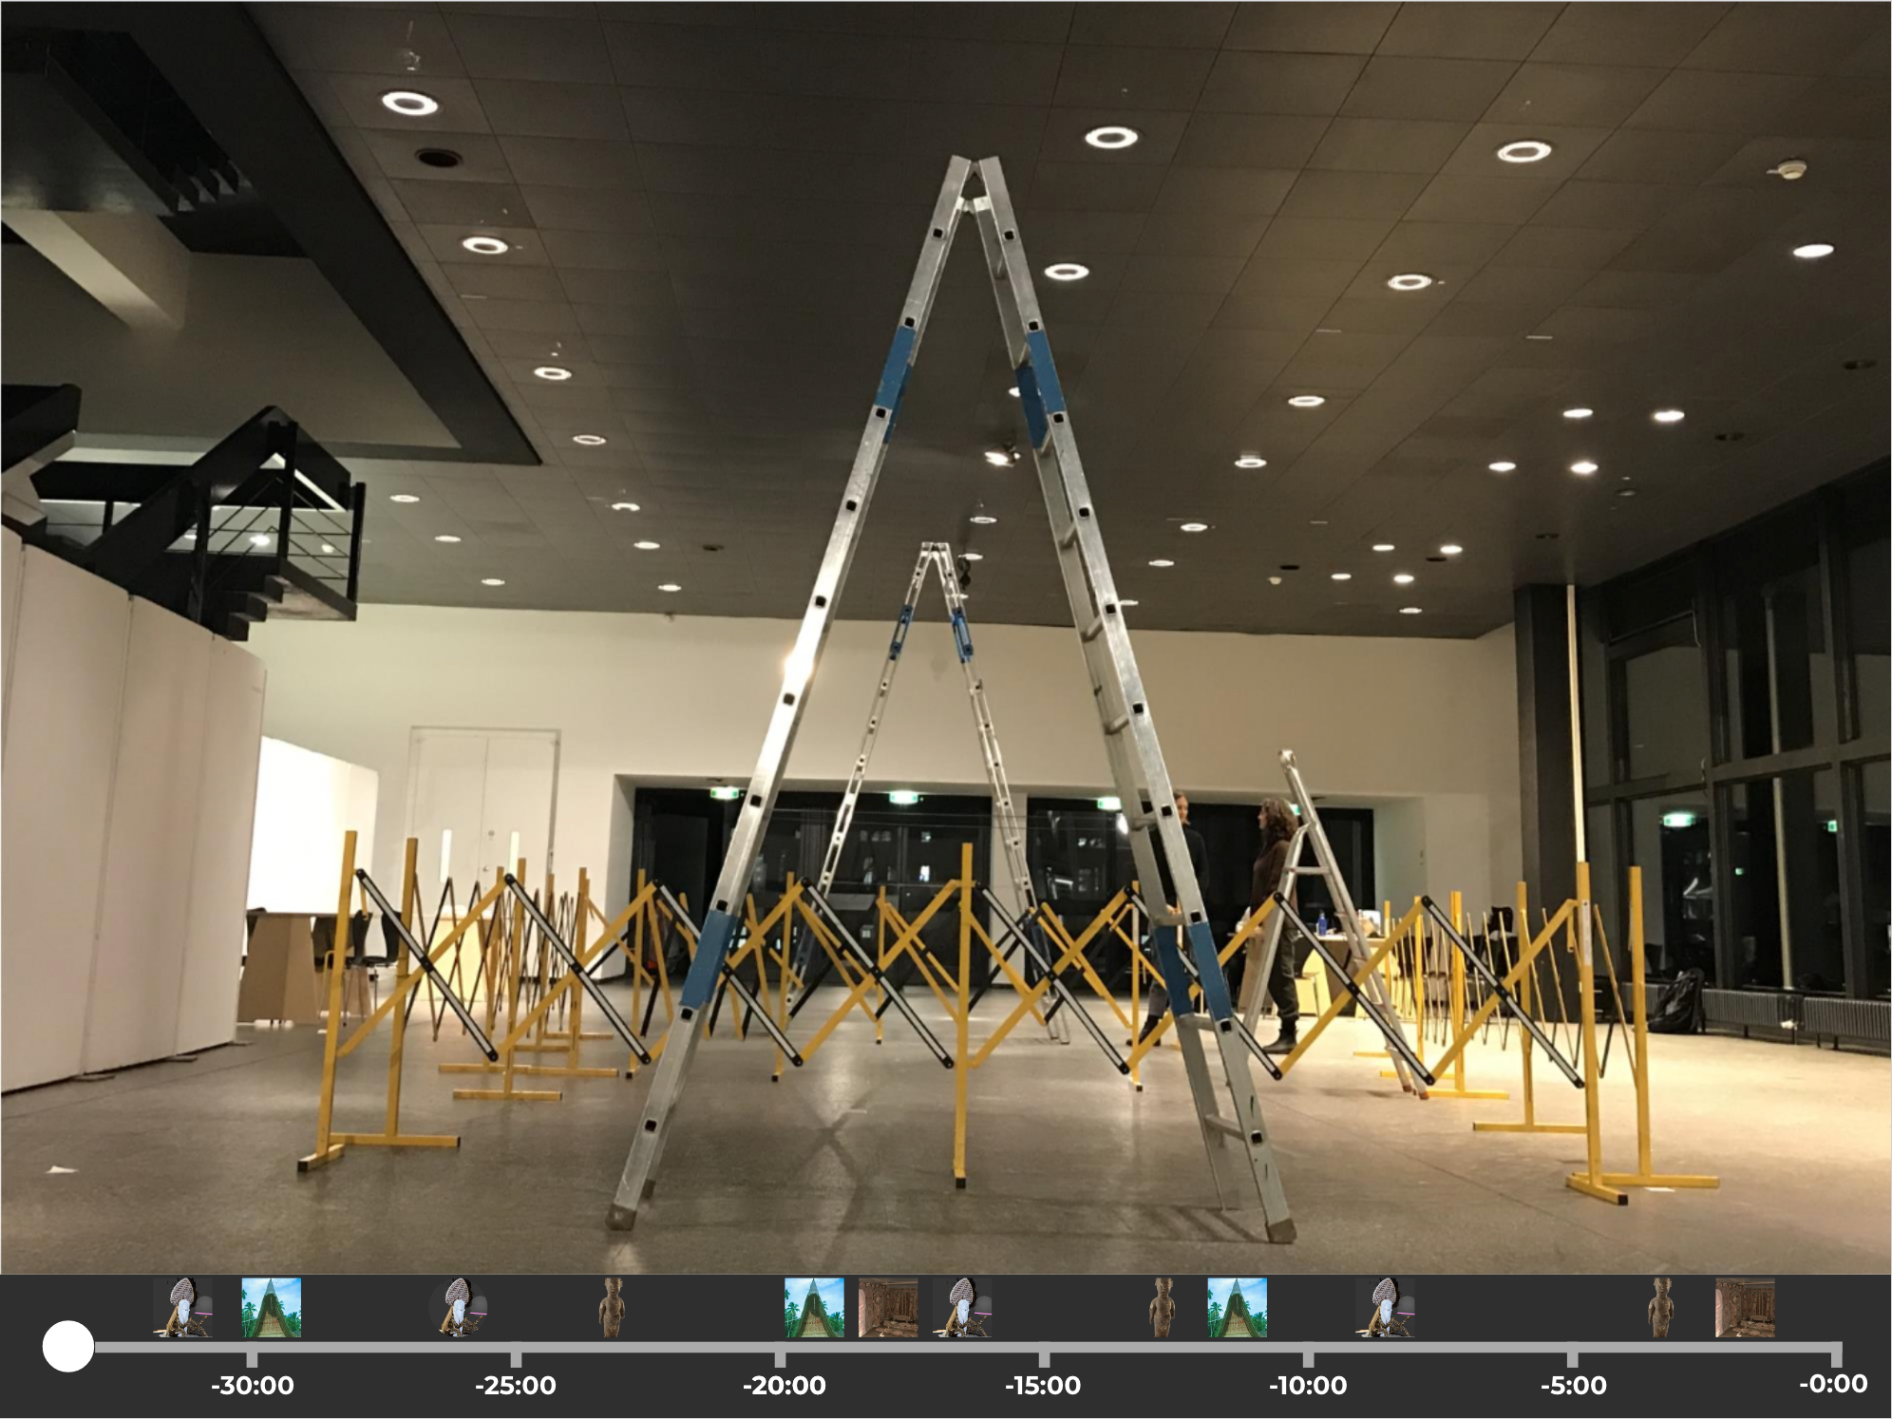

*Primary interface view (tour guide is in control)*

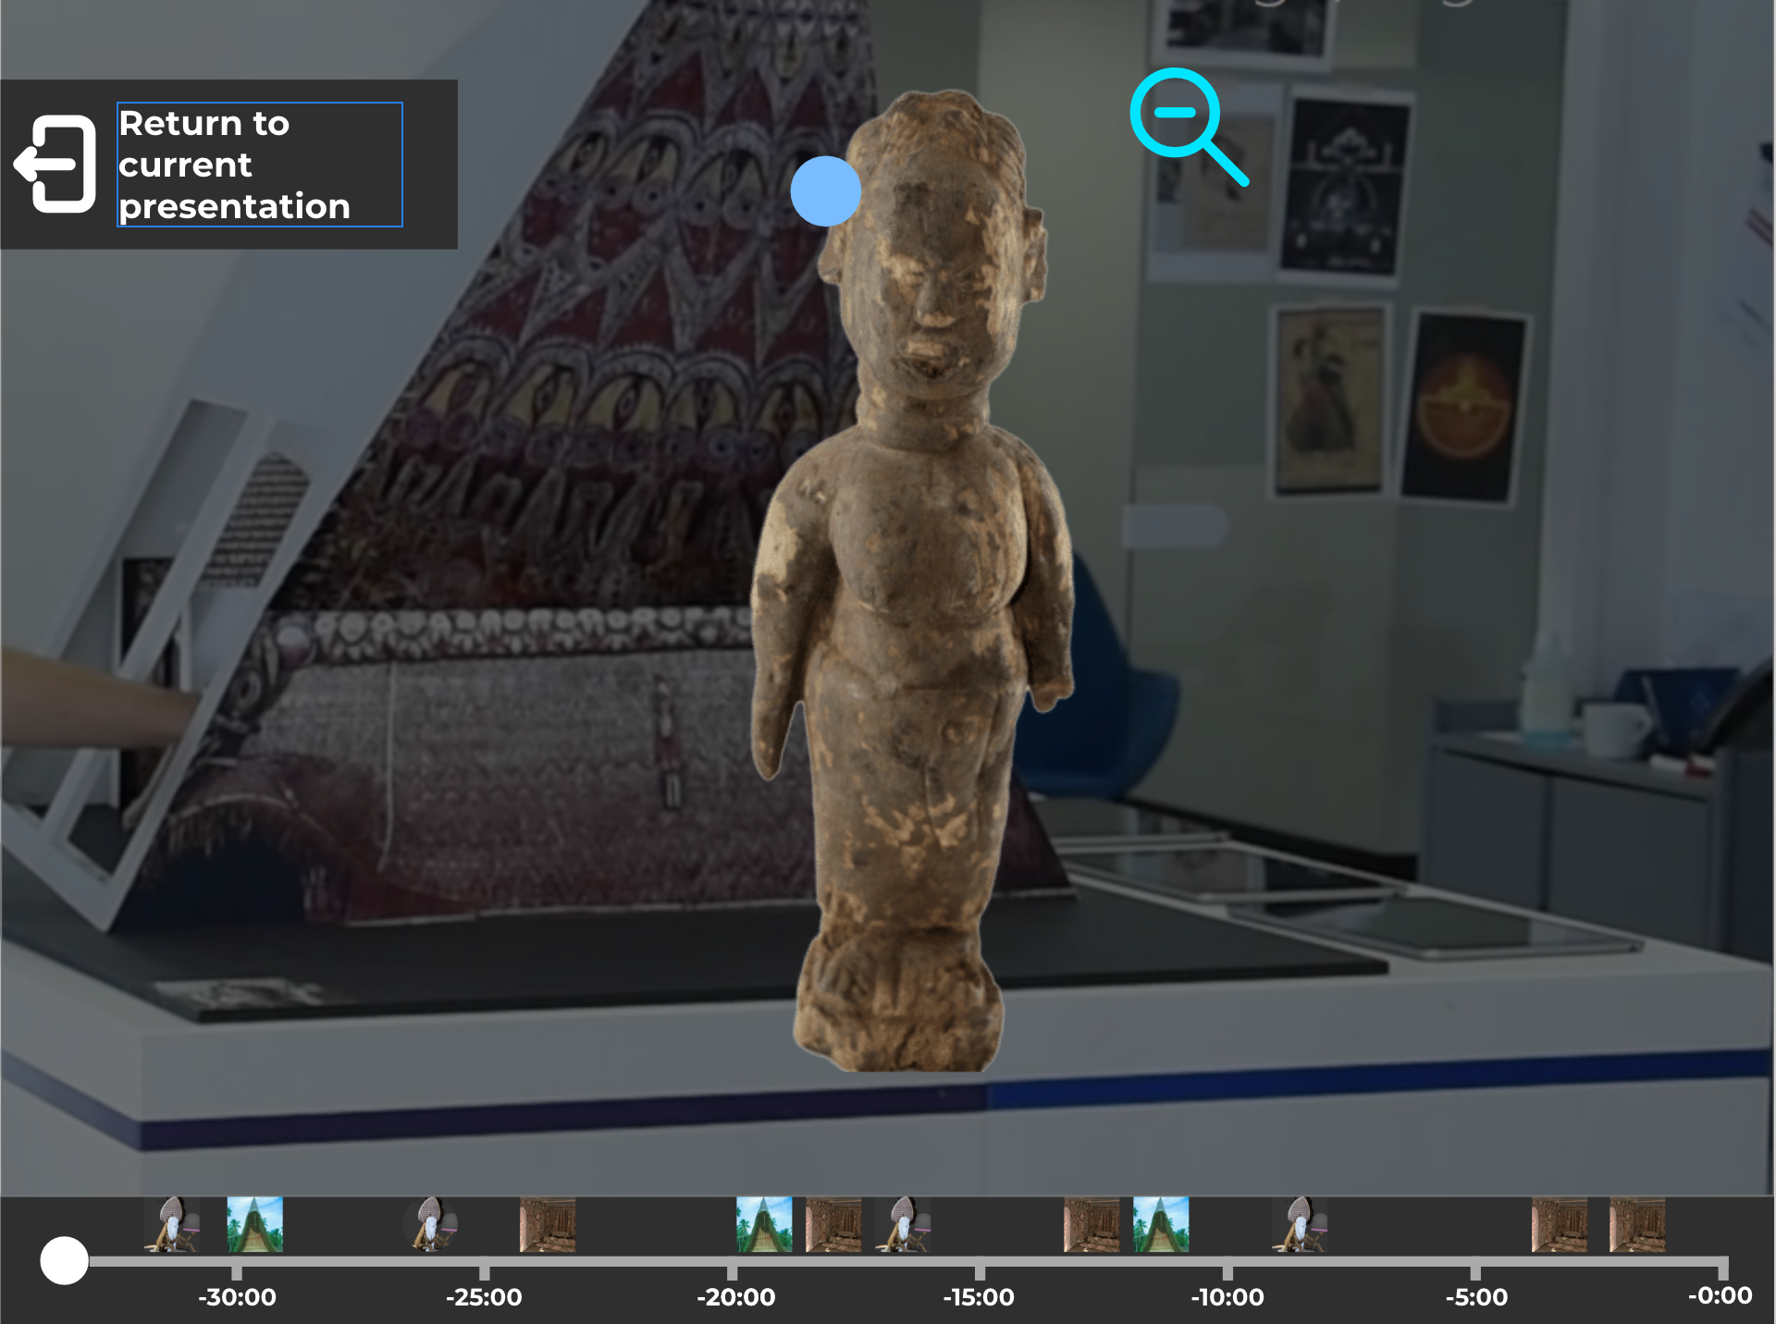

*Full view of the 3D model*

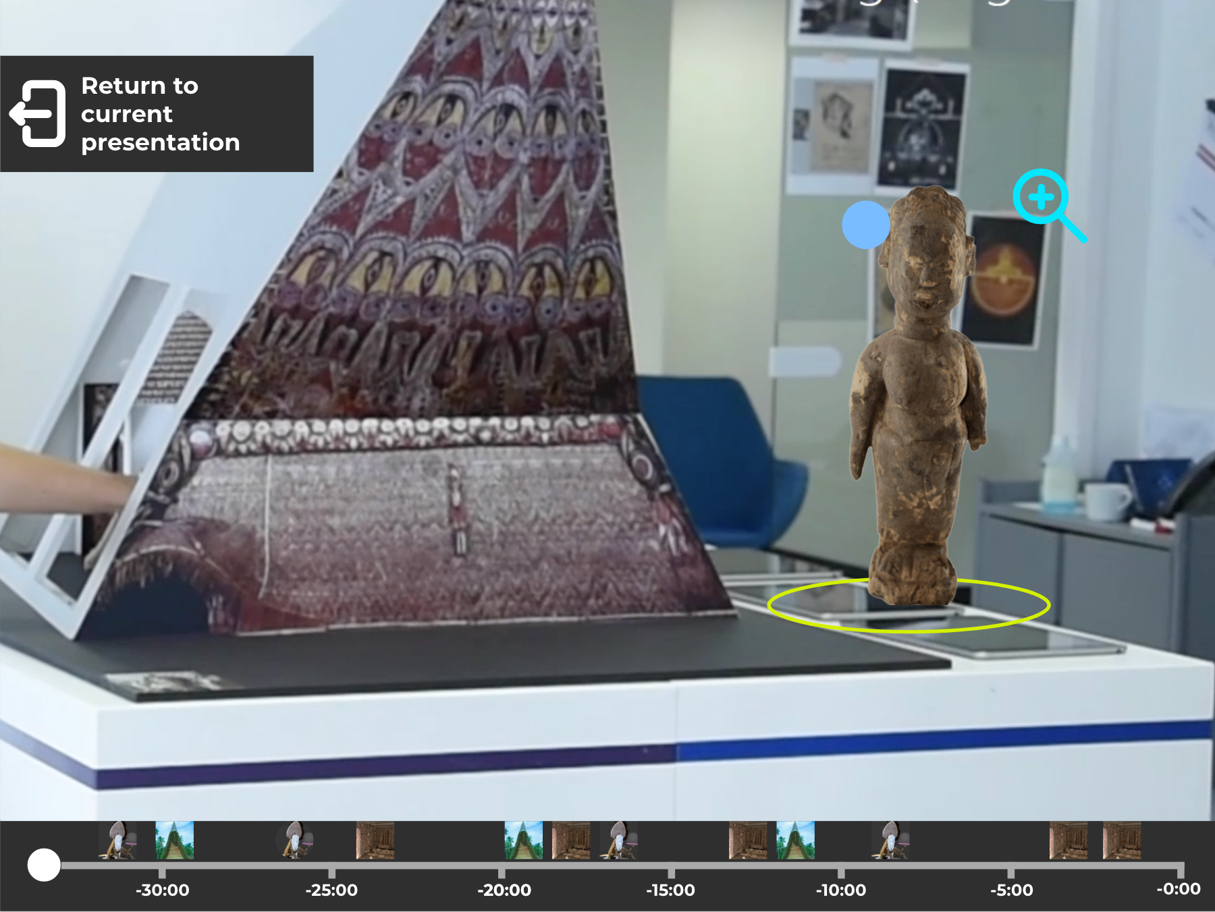

*Viewing the model in AR*

* Describe the media assets of your project.

We are going to need the 3D models of all objects that are being covered during the tour, as well as the timestamps of when they are being covered during the tour. We are also going to need a more detailed outline of the museum space in front of the House of the Abelam, to understand where the objects should be placed. We are reaching out to Cristina to request all of these assets.

## ***EXPERIENCE OVERVIEW***

* Describe the overall experience of the audience member. How do they join? Where do they start? What would they typically do? How would they conclude their experience? Emphasize the important moments and the transition moments.

During the tour, visitors follow the tour guide as they would regularly do, but are encouraged to pay attention to things that capture their attention and imagination, or to things that they would be curious to see next to one another. At any point, they can switch to the timeline mode, and, as described above, to dim out the rest of the application to take a closer look at the certain model.

During the designated time of the tour, the guide switches the mode of his and visitors’ devices to the Free Exploration mode, which presents a tour’s final timeline to the visitors, where they can see all the objects that were mentioned, as well as a reminder of when they were brought up by the guide. While being in the open space in front of the House of the Abelam, now the visitors can choose their objects of interest and engage with them (as we described above). They are also encouraged to share interesting findings with one another and the group, and ask the guide questions about the points of curiosity that arise from these findings. This timeline would be available to the visitors the entire time throughout the tour, but the special significance of this designated time in the end is the encouragement of this kind of interpersonal interaction.

* Describe a specific moment. Try to be as precise and thorough as possible. Where does the audience member look? How do they move? What is going on in their head? What is a practical, perhaps almost lyrical depiction of the scene? How does the system look like at that moment? How does it evolve? This should be able to show the reader that you care about details and that you are not only thing in broad, abstract terms.

Wilhelm is in his late twenties, he occasionally goes to museums with his girlfriend Jannike but often fails to understand the content and finds himself moving from piece to piece without making sense of the bigger picture of the exhibition and its content. To remedy this, Wilhelm periodically goes on group tours to listen to more engaging explanations and sometimes asks the tour guide questions. Wilhelm uses this AR application to both enhance his ability to see content that would otherwise not be possible to view like the interior of the tent, but also to view previous objects at will to cement his understanding of the exhibit and tour. Willhelm is fascinated by the tour guide’s description of the puti and quickly uses the timeline to navigate to the chamber model and information about it discussed around 15 minutes ago. He now has a better understanding of how the puti relates to the chambers and how both of these relate to the larger culture of the Abelam.

## ***CONCLUSION***

This project is a unique opportunity to respond to many challenges that are a part of today’s museum-going experience, as well as particular challenges of presentation of the House of the Abelam. Our timeline engages with the historical context of the space in front of the House as something social, but also challenges the hierarchies that are built into that context. It solves the issues of mediation such as the lack of contextualizing material by letting the visitor explore and create the context of their own. It allows the audience to interact with the objects and their specifications, and makes this interactivity a group experience. It expands on the idea of the existing House of the Abelam AR-App prototype as something that is not just an app but a storytelling format which reinforces the experience of the object and face-to-face communication. We believe that this is also a way for the guide to fascinate the visitors, and for them to feel the magic of the rituals and ceremonies by interacting so closely with objects that were building blocks of those ceremonies. This timeline also allows to establish a perfect balance between looking/listening and exploring, since this mode is allowed to be activated at any point of the tour if such interest exists. Finally, this is a perfect opportunity to cater to diverse interests of an audience with significantly different backgrounds in museum-going and this particular topic.